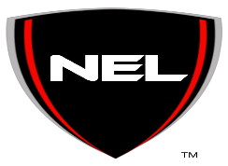NEL Information Sheet

Name:________________________________________________
Date of Birth:__________________________________________
Emergency Contact:_____________________________________
Phone number:____________________________________
Hat size:______________________________________________
Shirt size:_____________________________________________
Favorite Hobby:________________________________________
_____________________________________________________
Favorite color:_________________________________________

