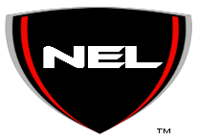The National Engineering League Code of Conduct
Representing NEL’s Vision and Mission the following guidelines are the Student Internship Code of Conduct during the internship commitment:

• Represent NEL in a professional manner at all times during the internship commitment.
• Be honest, ethical and trustworthy at all times.
• Allow NEL media consent to utilize photos, videos, art or other media which student is in or has created during internship with NEL
• Maintain confidentiality of work-related projects and personnel.
• Be prompt in communication responses and completion of tasks.
• Dress appropriately for any professional event that you attend on behave of NEL.
• Follow through with any NEL commitments.

Student's signature below indicates that Student acknowledges and agrees to NEL’s Internship Code of Conduct.

Signature: ________________________________ Date:__________________

