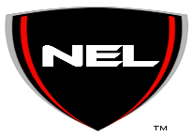The National Engineering League
Parental Consent Form

Part I: Permission to Participate if under the age of 18
I ______________________, give my son/daughter, ______________________, permission to participate in the NEL Internship program.
I also understand that my son/ daughter must meet the requirements outlined in The NEL Code of Conduct and Internship Report Guidelines to be eligible for program completion and The NEL Foundation Scholarship.
Signature of Parent/Guardian
_________________________________ Date ________________
Part II: Emergency Authorization
In the event that my son/daughter is participating in a NEL event outside of my presence and I cannot be reached in an emergency, I give permission to NEL staff to secure proper treatment for my son/daughter.
Signature of Parent/Guardian
___________________________________ Date______________________
Day time phone number: _______________________________
In case of emergency contact: ____________________________________
Alternate emergency contact: ___________________________________
Phone number: ________________________________________________

