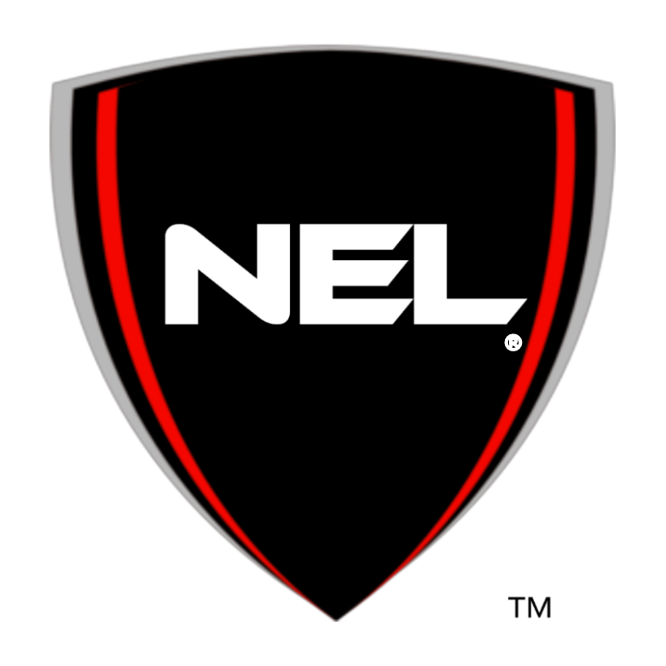

Official Internship Report Guideline

Name: _________________________________________________________

Intended Major: _________________________________________________

High School or College Name: _____________________________________

Current year of school: (freshman/sophomore/junior/senior) _______________

Phone: _________________________________________________________

Mailing Address: _________________________________________________

Email Address: ___________________________________________________

Current Date: ____________________________________________________

Agreed Upon Completion Date: ______________________________________

The National Engineering League® Internship Report Criteria

Research Topic:____________________________________________________

Specific Industry Problem Researched:____________________________________

General Requirements for the Engineering Research Report (College)
A. The student will select a research topic about a known problem related to his
or her particular career field or intended college major of study

B. Produce a double‐spaced 5-8 page report on a known problem within the
selected career/ industry of with at least 3 references in current APA format.

C. The report must include an introduction, findings, recommendations, and
conclusion section.

D. A data table and graph must be provided in the report under the finding
section.

General Requirements for the Engineering Research Report (HighSchool)
- The student will select a research topic related to his or her particular field/career of interest.

- The student will prepare a double spaced 2-3 page report on the subject with at least 3 references in current APA format.

- A data table and graph must be provided in the report under the findings section.

- The report must include an introduction, findings, recommendations, and
conclusion section.

Organize your report as follows:
Section I. General Information Section
Provide the topic of your research and explain why it is important to society. Describe how your research will be beneficial to The National Engineering League®. Describe your overall interest in your chosen field and how you plan on contributing to the advancement of the field as a professional.

Section II. Learning Objectives: Describe at least 3 key learning objectives that you wish to satisfy from conducting this research. List them clearly as you will need to refer backto them in Section V of your report.
Section III. Technical Section
This is the main focus of your report in which you will describe to the audience what you learned from the research on your topic. List at least one key industry problem that is related to your research and intended major. This section will give you a chance to communicate your thoughts, ideas, and discoveries in the language of a technical professional. As you enter your particular professional environment, it is important that you be able to communicate, relate, and speak the “technical language” of your particular industry. You can include anecdotes from references, drawings, charts, graphs, and photos.
Section IV. Development of Professional Skills
Discuss whether or not you met the goals of your learning objectives from Section II. Describe the ways in which participation in the NEL Internship Programhelped your professional growth. Share any challenges you expect in your future work environments and how you plan to respond to those challenges. List and describe the tools and skills you relied on to complete your research. List at least 3 people that you established professional networking contacts with during your research internships and what are their professional titles and job responsibilities.
Section V. Conclusion
Summarize how the research experience enhanced your knowledge of your chosen engineering field of study. Submit a photo dressed in professional attire & short video (approximately 45 seconds) describing what you learned during the research internship.

The completed report should be emailed to the following email addresses before the end of your agreed-upon timeline for completion.

internships@natengleague.net
nel.hr.mgmt@gmail.com
nel.career.mgmt@gmail.com

Please contact us at internships@natengleague.net and provide your chosen due date. Once the report has been submitted, the NEL staff will spend 1 week reviewing the report and then you will be scheduled for a post telephone conference.

